**BUSINESS ANALYTICS**

**Shehryar Irshad Bhatti (S2020005067)**

**Sec A**

**1ST dashboard**

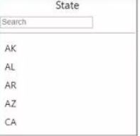**1 slicer**

A slicer is a data visualization tool that filters and segments data. It allows you to filter by specified dimensions. Slicers are visualizations on a Power BI that allow users to readily refine the data.

**2nd GAUGE**

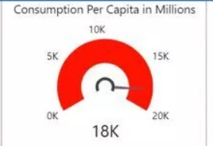A gauge chart is used to demonstrate progress towards a certain goal. It displays the maximum, value with relation to the desired value.it also described that how many people per capita are using their products

**3RD GAUGE**

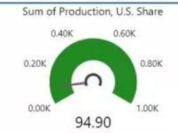A gauge chart is used to demonstrate progress towards a certain goal. It displays the minimum, value with relation to the desired value. It also describe the sum of production share of US

**4TH GAUGE**

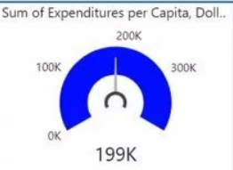A gauge chart is used to demonstrate progress towards a certain goal. It displays current value with relation to the desired value. Explains about the funds spent by the company.

**5th tree map**

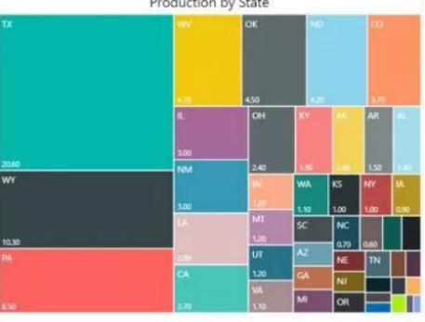Tree maps represent hierarchical data as a collection of nested rectangles it also describe about the production of the products by each state. Each level of the hierarchy is represented by a colored rectangle (branch) with smaller rectangles (leaves) within it.

**6th FILLED MAP**

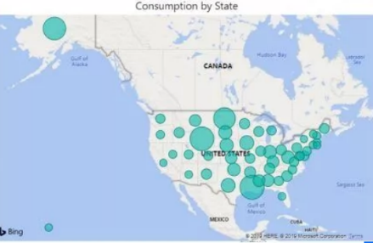A filled map is one that displays data points as Geo-spatial areas rather than points on a map. A continent, country, region, state, city, or county. This displays consumption of the products by each state

**2nd DASHBORD**

**1 STACK COLUMN CHART**

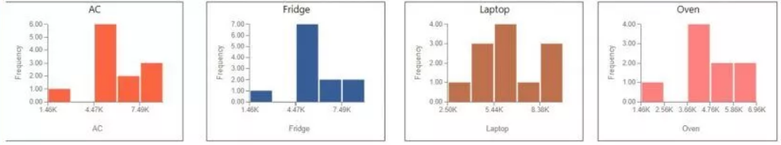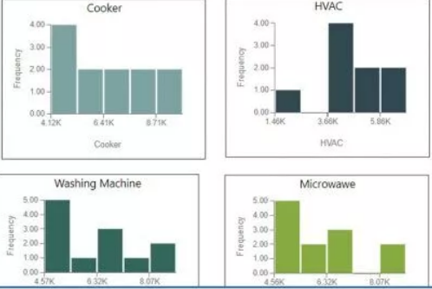charts that combine the Line chart and Column chart together in one visual. these charts describe the relationship between frequency and price of the different products like AC, FRIDGE, OVEN etc

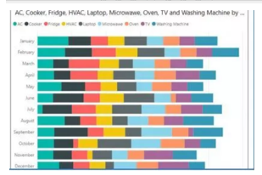

**2Stacked bar chart**

The stacked bar chart compares multiple dimensions to a single measure. The data value will be represented on the Y-axis in the Stacked bar chart, and the axis will represent the X-axis value.

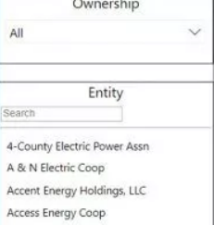**3rd dishoard**

**1 slicer**

A slicer is a data visualization tool that filters and segments data. It allows you to filter by specified dimensions. Slicers are visualizations on a Power BI that allow users to readily refine the data.

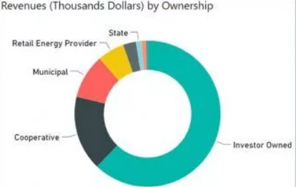**2 donut chart**

A doughnut chart, like a pie chart, depicts the relationship of parts to a whole. The main difference is that the center is empty, allowing for a label or icon. describe the revenue of different categories

**3 stacked area chart**

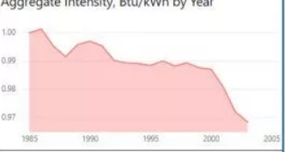Stacked Areas are used to depict a trend in data over time intervals. The difference is that Stacked Areas are used to show how various amounts combine to produce a whole, since it shows how each portion or category contributes to the total quantity.